**Lewis University  
CPSC 50900: Database Systems  
Term Project**

# **Movie Theater Reservation System**

**Movie Theater Reservation System Design** is basically aimed to provide complete information of the movie and schedule to the customer, according to which he/she can easily get a ticket instantly and can book a ticket on his/her favorite movies.

Admin can use Movie Ticketing System to insert and delete data such as movie descriptions, movie schedules, seating and auditorium details which will update the related webpage and will be accessible by the customers.

Admin can update changing according to the data in the database also admin can check the statistics information from the system.

Operate your cinema with better efficiency by automating reservation and ticketing process improve profitability and manage your cinema better by having access to key data in a centralized and systematic view and increase customer satisfaction by giving your customers what they want when it comes to the seat preference.

**Anil Potru, anilpotru@lewisu.edu**

***https://github.com/anilpotru/Movie_booking_db_design***

Table of Contents

Initial Proposal 2

Data Sources 2

Data Storage Alternatives 2

Relational Database Design Process 3

Relational Database Design 3

Data Definition Language (DDL) Scripts 3

Data Manipulation Language Scripts 4

Indexes 5

Views 5

Triggers 5

Transactions 5

Database Security 6

Locking and Concurrent Access 6

Backing Up Your Database 6

Python Programming 7

PHP Programming 7

Suggested Future Work 8

Activity Log 8

# Initial Proposal

There are a few assumptions we have to bear in mind:

* contemporary multiplex movie theaters can have one or more auditoriums within a larger complex,
* each auditorium can have a different number of seats,
* seats are numerated with row number and seat position within a row,
* a movie can have multiple screenings at different times, or it can be screened simultaneously in a different auditorium,
* for each screening a seat can be reserved/sold only once,
* we want to track who entered each reservation/sale into the system.

Admin can use Movie Ticketing System to insert and delete data such as movie descriptions, movie schedules, seating and auditorium details which will update the related webpage and will be accessible by the customers.

Admin can update changing according to the data in the database also admin can check the statistics information from the system.

Operate your cinema with better efficiency by automating reservation and ticketing process improve profitability and manage your cinema better by having access to key data in a centralized and systematic view and increase customer satisfaction by giving your customers what they want when it comes to the seat preference.

**Short table structure descriptions are given below:**

1. The movie table contains data about movies which will be shown in the theater. The primary key is id, which is auto_incremented like all primary keys in all other tables. The only mandatory data is title.

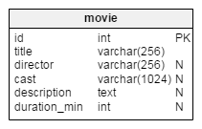

All fields have meanings according to their name. The column duration_min could be used to disable inserting a new screening or to show an alert message in case we want to enter a screening in an auditorium where the previous screening is still in progress:  
previous screening start time + duration_min of it > this screening start time

1. The auditorium table identifies all auditoriums in theater. All data is mandatory.

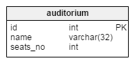

The seats_no field can be used to calculate percentage of availability of auditoriums for a selected screening/movie/auditorium/date range. This is an example of data redundancy because we could get the number of seats for each auditorium by counting them in the seat table. In this example it might not improve performance significantly. I show it here as an idea that could help with designing more complex models. If we set up the database this way we must bear in mind that if we change one piece of data, we also have to change others. If we add or delete data from the seat table we have to adjust values seats_no in the auditorium table.

1. The screening table contains data of all screenings and all fields are mandatory. A screening must have a related movie, auditorium and start time. We can’t have two showings in same auditorium at the same time. We can define a unique key consisting of auditorium_id and screening_start. This setup is better than defining a unique key consisting of movie_id, auditorium_id, and screening_start because that would allow us to enter screenings of two different movies at the same time in the same auditorium.

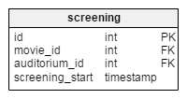

Vertabelo SQL preview code for this table looks like this

|  |
| --- |
|  |
|  |

1. The seat table contains a list of all seats we have in auditoriums with each seat assigned to strictly one auditorium. All fields are mandatory.

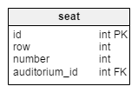

1. The reservation_type table is a dictionary of all reservation types (by phone, online, in person). All fields are mandatory.

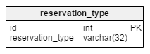

1. The employee table lists all employees using the system. All fields are mandatory.

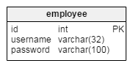

In complex systems there are usually more roles so we need to have a role dictionary and employee/user-role connection. In our example we have only one role: the same person inserts reservations and sells tickets.

1. The reservation and seat_reserved tables are the main tables of our system. This is why I listed them last. All other tables can exist without reservation tables but without the reservation tables we would lose the reason for designing the whole database in the first place.

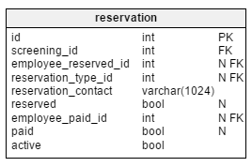

The reservation table stores data about a ticket reservation and/or sale. If we have a reservation, the attribute reserved would be set to True, the reservation_type_id would be set according to the origin of the reservation and the employee_reserved_id would contain the id_employee value of the person who entered data (it would be empty if the reservation had been done online by the customer). In the same way, if tickets were sold, the employee_paid_id would be filled with the id_employee value of the person who sold tickets, the attribute paid would be set to True. The active attribute identifies if a record is still valid. If tickets were sold this attribute would always be True and the reservation without sales would be active until 30 min before screening starts

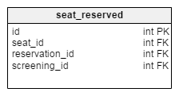

The seat_reserved table enables us to make a reservation or one payment for multiple seats. After the employee checks a few free seats on the interface, one record would be added to this table for each of them. If we want to check which seats are free or taken we can check the values in this table joined to the reservation table where reservation.active = True.

Additionally an admin can update the **webpage** changing the movies, schedules, auditoriums information according to the database. And also can use the **webpage** to check the statistics information from the system.

# Data Sources

**Movie Theater Reservation System Design** entities and their attributes:

**Movie Entity**: Attributes of Movie are id, title, director, cast, description, duration_min

**Auditorium Entity**: Attributes of Auditorium are id, name, seats_no

**Screening Entity**: Attributes of Screening are id, movie_id, auditorium,id, screening_start

**Seat**: Attributes of Seat are id, row, number, auditorium_id

**Reservation_type**: Attributes of Reservation_type are id, reservation_type

**Employee**: Attributes of Employee are id, username, password

**Reservation**: Attributes of Reservation are id, screening_id, employee_reserve_id, reservation_type_id, reservation_contact, reserved, employee_paid_id, paid, active

**Seat_reserved**: Attributes of Seat_reserved are id, seat_id, reservation_id, screening_id

Please find the github link for the sample data sources attachments required for the above entities.

Below is the sample data of the movie entity json

# 

We have seen that RDBMS is better approach for the above database design. Where it guarantees the granularity and relationship between the tables.

However, as the system grows if we have below requirements the existing RDBMS may not be suitable for future requirements.

1. We have tons of data like movies information, actors, crew, comments and reviews

2. We need to have faster search

3. We need to run queries for analytics

So, alternatively we can use NoSQL as the option to acknowledge the above issues. MongoDB, Cassandra, and CouchDB are the examples of NoSQL.

# Relational Database Design Process

**Movie Theater Reservation System Design** entities and their attributes:

**Movie Entity**: Attributes of Movie are id, title, director, cast, description, duration_min

**Auditorium Entity**: Attributes of Auditorium are id, name, seats_no

**Screening Entity**: Attributes of Screening are id, movie_id, auditorium,id, screening_start

**Seat**: Attributes of Seat are id, row, number, auditorium_id

**Reservation_type**: Attributes of Reservation_type are id, reservation_type

**Employee**: Attributes of Employee are id, username, password

**Reservation**: Attributes of Reservation are id, screening_id, employee_reserve_id, reservation_type_id, reservation_contact, reserved, employee_paid_id, paid, active

**Seat_reserved**: Attributes of Seat_reserved are id, seat_id, reservation_id, screening_id

Please find the uploaded DDL script for the relations creation that is created by **Vertabelo**.

The detailed relationships between tables is mentioned in the **a) initial proposal** section



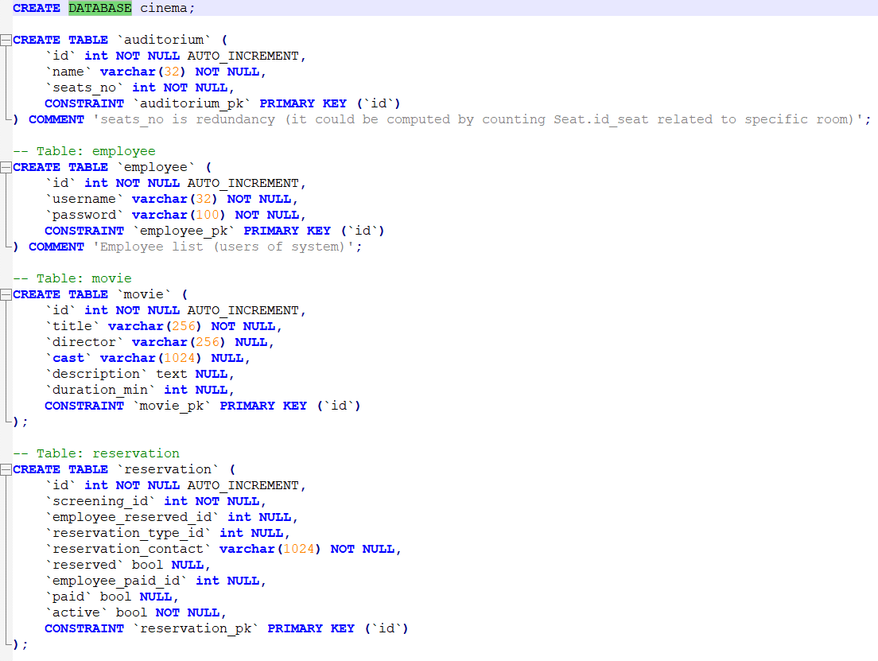

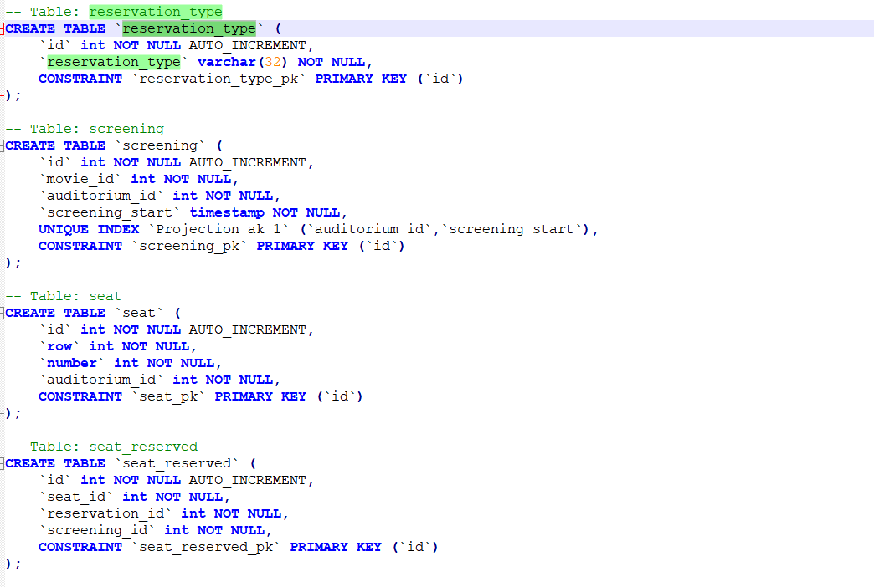

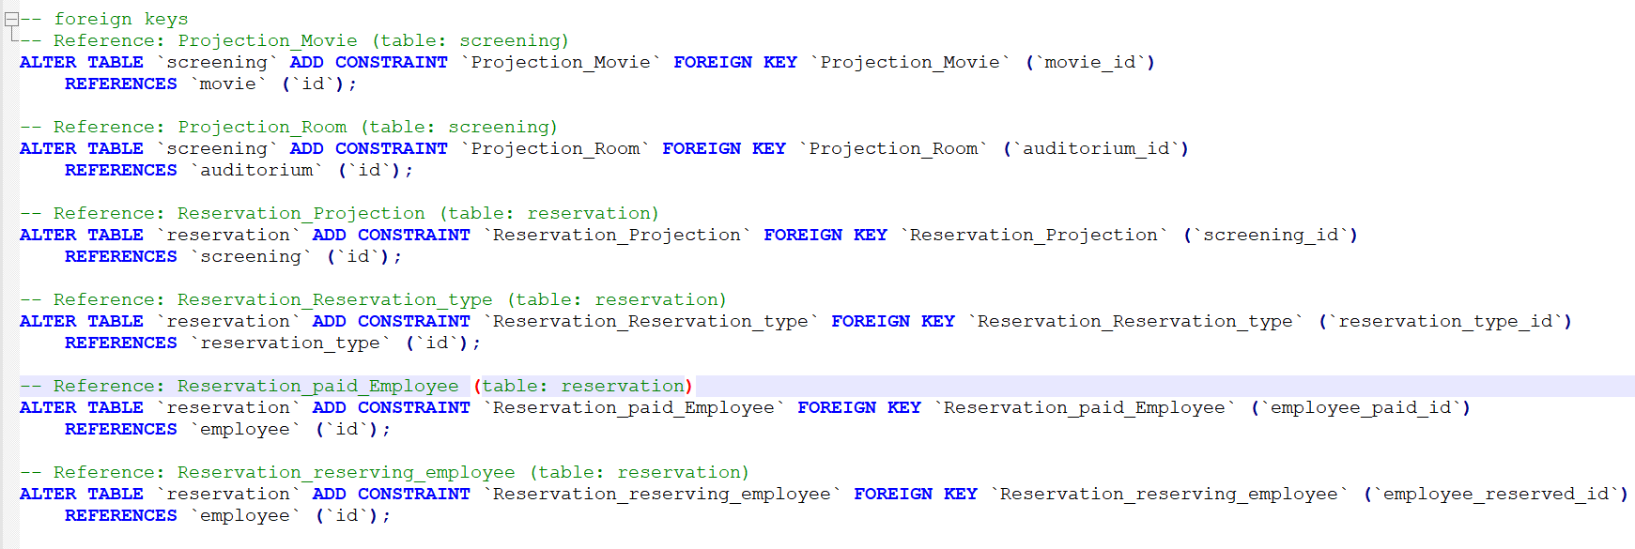

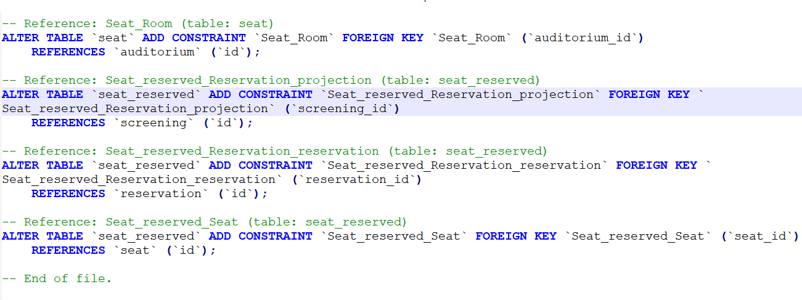

Please find below/or in github the generated relationships document from the Vertabelo



Below is the script to get the relationships between the tables in cinema database;

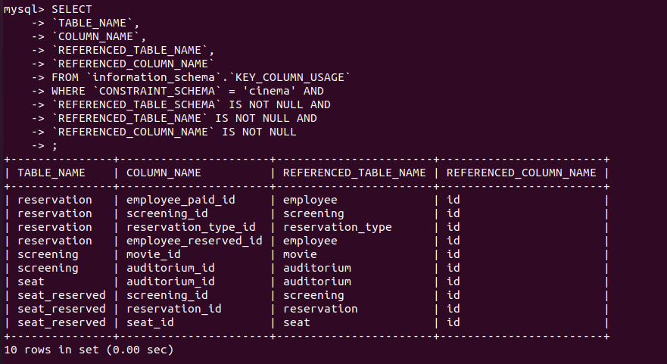

# Relational Database Design

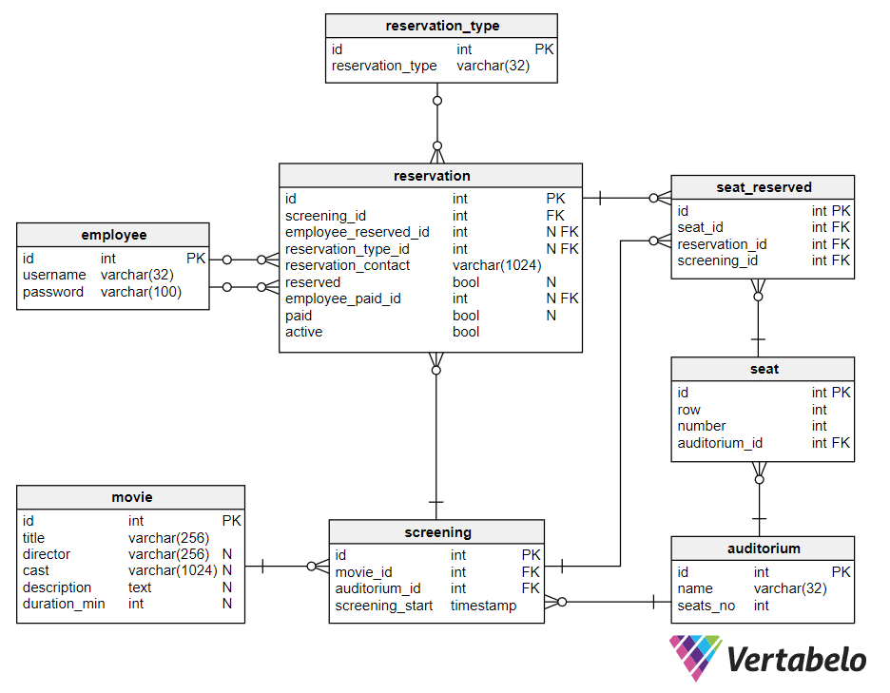

Please find the uploaded DDL script for the relations creation that is created by **Vertabelo**.

The detailed normalization analysis, relationship is mentioned in the **a) initial proposal** section

# Data Definition Language (DDL) Scripts

Please find the below DDL scripts generated by Vertabelo





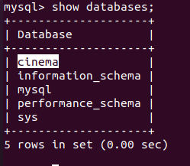

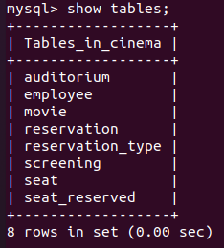

Below are the queries to insert queries

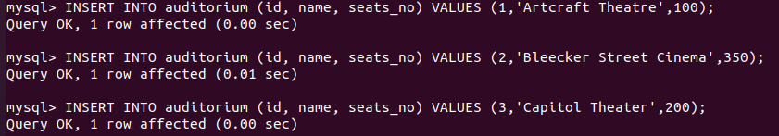

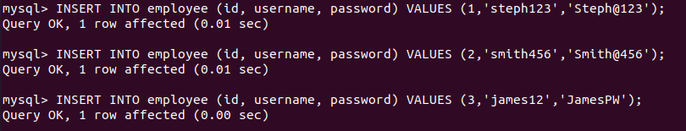

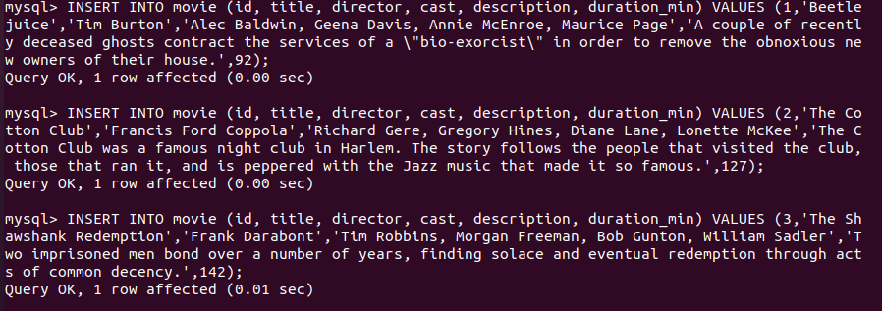

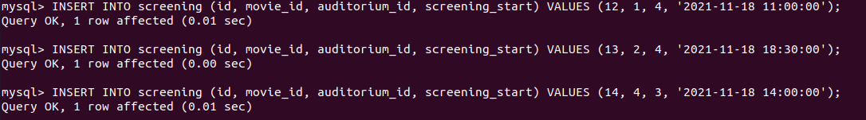

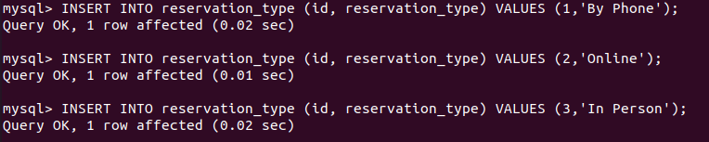

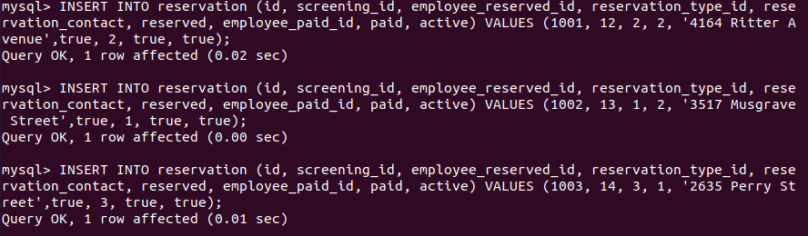

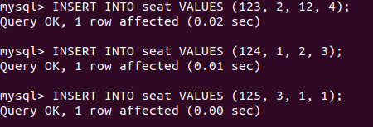

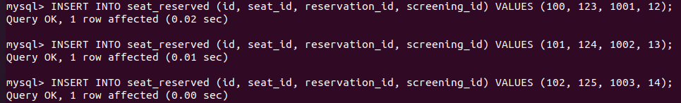

# Data Manipulation Language Scripts

Please find the attached/uploaded in the github DML queries of the above



Please find screenshots for the above queries.

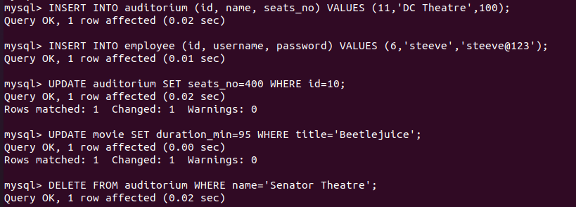

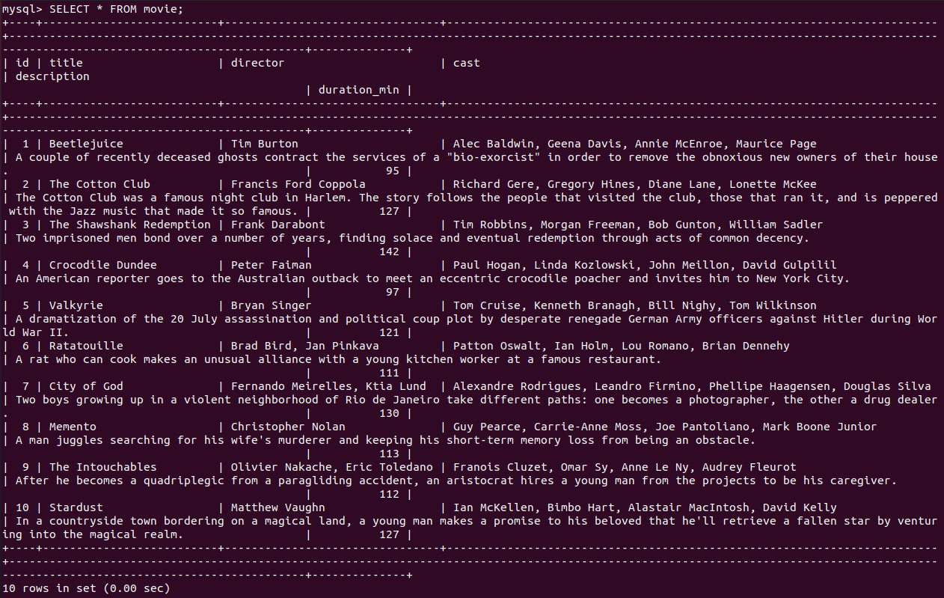

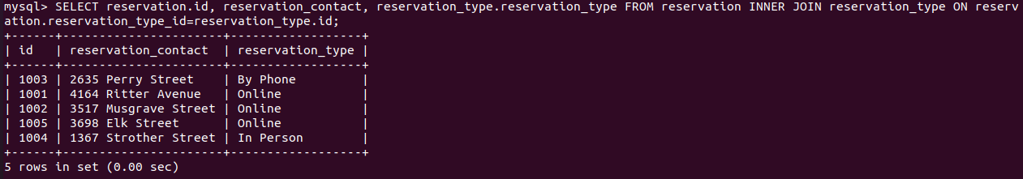

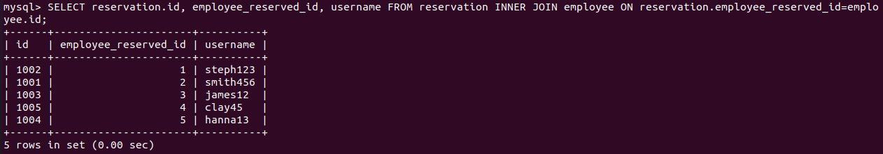

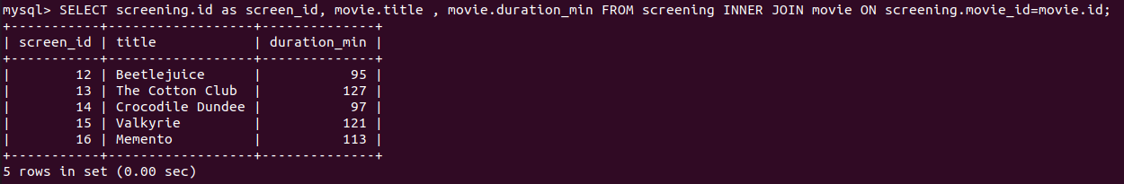

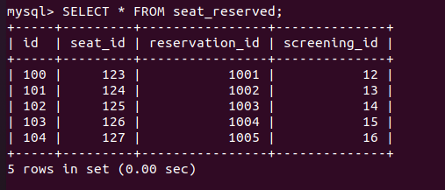

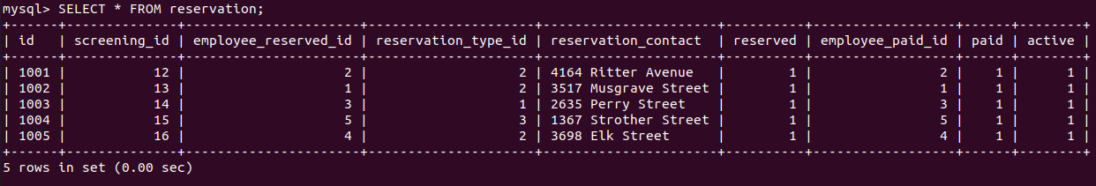

# Indexes

*Description: Improve the performance of your design by adding indexes to various tables. Show the SQL needed to add the indexes. Explain why you chose the ones you added. Explain how you would demonstrate the impact the indexes had on the performance of various queries.*

*Rubric: Your work will be graded as follows:*

* *6 points for clearly defining at least three indexes and explaining why you chose them.*
* *3 points for showing the sql needed to generate the indexes*
* *3 points for explaining how you would demonstrate the performance improvement afforded by the indexes.*

*Total points possible: 12*

ENTER YOUR INDEX WORK HERE

# Views

*Description: Add two views to your database to provide easy access to combinations of data from multiple tables.*

*Rubric: Your work will be graded as follows:*

* *2 points for including the SQL for generating the two views in your Word document*
* *2 points for including screenshots for the data contained in each view in your Word document*
* *2 points for explaining why each view is a valuable addition to your database*
* *2 points for explaining who might benefit most from having access to each view.*

*Total points possible: 8*

ENTER YOUR WORK WITH VIEWS HERE

# Triggers

*Description: Add a trigger to a table so that data will be updated when a certain event occurs*

*Rubric: Your work will be graded as follows:*

* *2 points for including the SQL for the trigger in your Word document*
* *2 points for clearly explaining the purpose of the trigger*
* *2 points for a screenshot and explanation that shows the trigger in action.*

*Total points possible: 6*

ENTER YOUR WORK WITH TRIGGERS HERE

# Transactions

*Description: Demonstrate that you know how to define and use a transaction. Why are transactions important for ensuring ACID behavior?*

*Rubric: Your work will be graded as follows:*

* *3 points for clearly explaining the importance of transactions to ensuring ACID behavior*
* *3 points for including a screenshot and accompanying explanation of a MySQL transaction.*

*Total points possible: 6*

ENTER YOUR WORK WITH TRANSACTIONS HERE

# Database Security

*Description: Identify the different kinds of users who will use your database. Write GRANT statements to define the privileges for these different kinds of users.*

*Rubric: Your work will be graded as follows:*

* *6 points for clearly identifying and describing the various kinds of users who will use the databases and identifying and justifying what privileges each should have.*
* *4 points for writing GRANT statements that assign privileges to these different kinds of users.*
* *4 points for demonstrating with screenshots that your GRANT statements do distinguish among different kinds of users in regard to what they can do with the database.*

*Total points possible: 14*

ENTER YOUR WORK WITH DATABASE SECURITY HERE

# Locking and Concurrent Access

*Description: Explain the purpose of locking tables and show how to do that to prevent inconsistencies that may arise in your data when concurrent transactions take place.*

*Rubric: Your work will be graded as follows:*

* *3 points for clearly explaining an example that shows why you should lock tables to prevent inconsistencies.*
* *3 points for providing a screenshot and accompanying explanation of locking tables.*

*Total points possible: 6*

ENTER YOUR WORK WITH LOCKING AND CONCURRENT ACCESS HERE

# Backing Up Your Database

*Description: How you will back up your database. What commands will you issue? How frequently will the commands run? How can they be automated? Where will the backups be stored?*

*Rubric: Your work will be graded as follows:*

* *12 points for clearly explaining and justifying your database backup strategy, including the frequency with which you will back up the database, how you will automate backups, where you will store them, and how you will secure them. You will earn three points for addressing each factor (frequency, location, automation, and security)*
* *3 points for providing a screenshot of the command you would issue to back up the database and for including a portion of the resulting file.*

*Total points possible: 15*

ENTER YOUR WORK ON DATABASE BACKUPS HERE

# Python Programming

*Description: Write a Python program that generates a report that contains a subset of the data from your database. Include the code for your Python program in your Word document, and also post the program to your GitHub repository.*

*Rubric: Your work will be graded as follows:*

* *12 points for writing a Python script (and including its code in the Word doc) that will pull data from a database and store it to a text file and present it to the screen. Your code must have comments in it that explain how it works. You will be awarded 3 points for successfully connecting to the database, 3 points for successfully querying it, and 4 points for presenting the data to the screen and to a file. Internal comments count for 2 points.*
* *2 points for posting the code to GitHub*
* *4 points for showing a screenshot of your running the script and showing the results it produces on the screen.*

*Total points possible: 18*

ENTER YOUR PYTHON DATABASE PROGRAMMING WORK HERE

# PHP Programming

*Description: Build an HTML form that enables the user to specify criteria to search by. Use PHP to show the results of the query on a resulting web page. Make sure you include protections against an SQL injection attack. Include your HTML and PHP code in your Word document, and also post the files to your GitHub repository.*

*Rubric: Your work will be graded as follows:*

* *4 points for writing an HTML form the user will use to enter search criteria*
* *8 points for a PHP script that uses the search criteria and returns results*
* *4 points for an HTML page that shows the results*
* *4 points for explaining what SQL injection might be run on your website and explaining how you prevented it.*
* *4 points for providing screen shots of your PHP website in action.*
* *2 points for posting your code to GitHub*

*Total points possible: 26*

ENTER YOUR PHP DATABASE APP PROGRAMMING WORK HERE

# Suggested Future Work

*Description: Describe the limitations of your current database and explain how you or someone else could improve the design to address these shortcomings. Also describe how you might take advantage of leverage cloud services to increase the performance and availability of your database. Finally, explain the advantages and disadvantages of storing your data in a NoSQL format instead.*

*Rubric: Your work will be graded as follows:*

* *3 points for clearly describing the limitations of your databases*
* *3 points for explaining how you would address these shortcomings*
* *3 points for explaining how you might migrate the database to the cloud and describing what advantages you might gain from doing that.*
* *3 points for explaining the advantages and disadvantages of storing your data in a document-based NoSQL format instead.*

*Total points possible: 12*

ENTER YOUR SUGGESTED FUTURE WORK IDEAS HERE

# Activity Log

|  |  |  |
| --- | --- | --- |
| *Date* | *Name* | *Comments / Challenges* |
| 3rd Nov 2021 | Anil Potru | Worked on the use case, and created vertabelo account |
| 5th Nov 2021 | Anil Potru | Worked on the movie ticket booking ER design |
| 6th Nov 2021 | Anil Potru | Created the tables and relations using vertabelo |
| 12th Nov 2021 | Anil Potru | Installed mysql and exported the DDL and documents from vertabelo |
| 16th Nov 2021 | Anil Potru | Worked on the DML queries and sample data for insertion, downloaded the sample movies list from internet. |
| 18th Nov 2021 | Anil Potru | Worked on the update, select ,delete and join queries. |
|  |  |  |